Week 3: Predictive Modelling and Churn Analysis Report
Intern Name:
Date of Submission: 1st September, 2025

Team Members:
- Hammad Mengrani
- Kareem Mamdouh
- Laiba Jawaid
- Priyanka Kute
- Reeba Joshi
- Rifat Islam
- Sumaya Mateen

Predictive Model Link:
https://colab.research.google.com/drive/1RJ5kLoNZNjHsgvq0nsiGxP2TKNrLU4j4?usp=sharing

1. Introduction
- Objective:
The primary objective of this analysis is to identify learners at high risk of churning (discontinuing courses or not returning to the platform) and to uncover the key factors contributing to drop-offs. By applying churn analysis, predictive modeling, and actionable recommendations, this report aims to help the platform move from a reactive to a proactive retention strategy. The insights will support improved learner engagement, higher course completion rates, and timely interventions to enhance the overall learning experience.
2. Data Preparation
- Data Cleaning:
Here are the approaches used for cleaning the dataset:
- Converted columns to appropriate data types (Datetime, INT, Object, Float) and trimmed unnecessary spaces.
- Standardized key text fields (Name, Major, Institution, Country) by correcting misspellings, normalizing spaces, removing symbols/digits, ensuring consistent capitalization, and translating non-English text.
- Mapped inconsistent values to standard forms and removed invalid or unusually short entries.
- Checked for duplicate records and handled them appropriately.
- Filled missing values: First Name → “Not Specified”; Institution/Major → group-based imputation or “Not Specified”; Opportunity Start Date → group mode or calculated from end dates for competitions.
These steps ensured data accuracy, consistency, and completeness for analysis.
- Feature Selection:
- Features used in churn analysis: Engagement_Score, Applications_per_User, User_Success_Rate, Apply_vs_Start_Gap.
- Features used in model training: Quick_Applicant, Late_Applicant, Signup_to_Apply_Days, Course_Duration_Days, Region_Normalized_Applications, Opportunity_Popularity.
- Target variable: Churned (binary, 1 = churned, 0 = retained).
3. Exploratory Data Analysis (EDA)
- Descriptive Statistics:
The statistical summary provides an overview of the key numerical features in the dataset. It includes measures such as count, mean, standard deviation, minimum, maximum, quartiles, and range.

Column Name | Count | Mean | Std | Min | 25% | 50% | 75% | Max | Range
Status Code | 8,558 | 1052.23 | 21.67 | 1010.00 | 1030.00 | 1050.00 | 1070.00 | 1120.00 | 110.00
Age | 8,558 | 25.39 | 4.40 | 6.00 | 23.00 | 25.00 | 27.00 | 59.00 | 53.00
Current_Age | 8,558 | 0.00 | 1.00 | -4.40 | -0.54 | -0.08 | 0.37 | 7.65 | 12.05
Signup_to_Apply_Days | 8,558 | -0.00 | 1.00 | -3.59 | -0.47 | -0.47 | 0.49 | 4.40 | 7.99
Course_Duration_Days | 8,558 | 0.00 | 1.00 | -1.10 | -0.74 | -0.31 | 0.59 | 1.91 | 3.01
Signup_Month | 8,558 | 6.21 | 3.47 | 1.00 | 3.00 | 6.00 | 9.00 | 12.00 | 11.00
Signup_Hour | 8,558 | 12.31 | 6.83 | 0.00 | 6.00 | 13.00 | 18.00 | 23.00 | 23.00
Quick_Applicant | 8,558 | 0.52 | 0.50 | 0.00 | 0.00 | 1.00 | 1.00 | 1.00 | 1.00
Gender_Encoded | 8,558 | 1.42 | 0.50 | 1.00 | 1.00 | 1.00 | 2.00 | 4.00 | 3.00
Is_Successful | 8,558 | 0.48 | 0.50 | 0.00 | 0.00 | 0.00 | 1.00 | 1.00 | 1.00
Same_Day_Application | 8,558 | 0.40 | 0.49 | 0.00 | 0.00 | 0.00 | 1.00 | 1.00 | 1.00
Late_Applicant | 8,558 | 0.39 | 0.49 | 0.00 | 0.00 | 0.00 | 1.00 | 1.00 | 1.00
Opportunity_Popularity | 8,558 | 0.00 | 1.00 | -1.75 | -0.72 | -0.37 | 0.68 | 1.78 | 3.52
Popular_Opportunity | 8,558 | 0.47 | 0.50 | 0.00 | 0.00 | 0.00 | 1.00 | 1.00 | 1.00
Engagement_Score | 8,558 | 0.47 | 0.31 | 0.00 | 0.20 | 0.40 | 0.65 | 1.00 | 1.00
Apply_vs_Start_Gap | 8,558 | -22.72 | 291.01 | -998.00 | -181.00 | 1.00 | 189.00 | 570.00 | 1568.00
Applications_per_User | 8,558 | 8.33 | 10.48 | 1.00 | 2.00 | 5.00 | 11.00 | 83.00 | 82.00
Unique_Categories_per_User | 8,558 | 2.25 | 1.26 | 1.00 | 1.00 | 2.00 | 3.00 | 5.00 | 4.00
Applications_for_Opportunity | 8,558 | 705.87 | 404.97 | 4.00 | 419.00 | 559.00 | 980.00 | 1423.00 | 1419.00
Region_Normalized_Applications | 8,558 | 0.49 | 0.29 | 0.00 | 0.29 | 0.39 | 0.69 | 1.00 | 1.00
User_Success_Rate | 8,558 | 0.48 | 0.34 | 0.00 | 0.22 | 0.49 | 0.69 | 1.00 | 1.00

- Visualization:
Distribution of Signup_to_Apply_Days: Most learners apply relatively quickly after signing up, as evidenced by the high concentration of data points near zero on the graph.
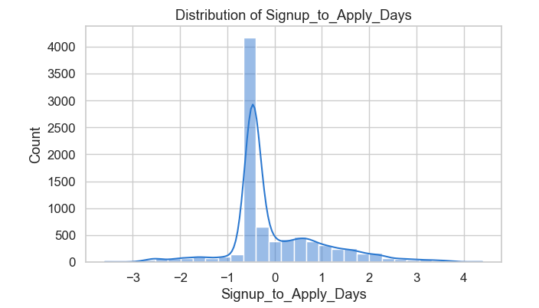

Distribution of Quick_Applicant: The number of quick applicants (value 1) is nearly equal to those who are not (value 0).
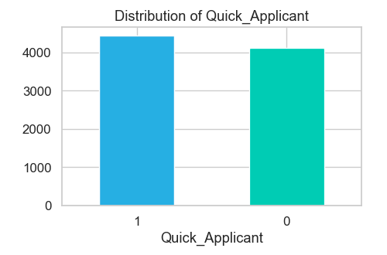
Distribution of Late_Applicant: There are significantly more non-late applicants (value 0) than late applicants (value 1).
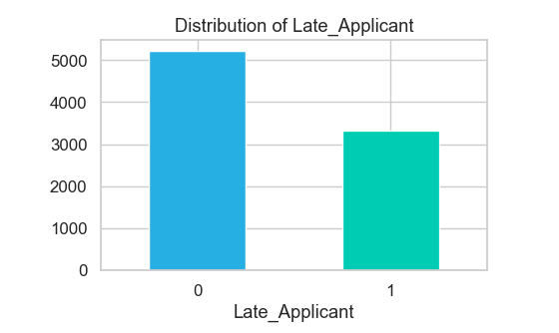

Churn Distribution: More users are retained (value 0) than churned (value 1).
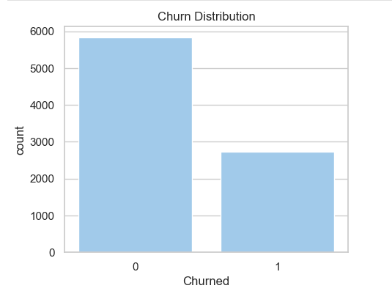
Churn by Gender: Male learners have a higher count of both retained and churned users compared to other genders.
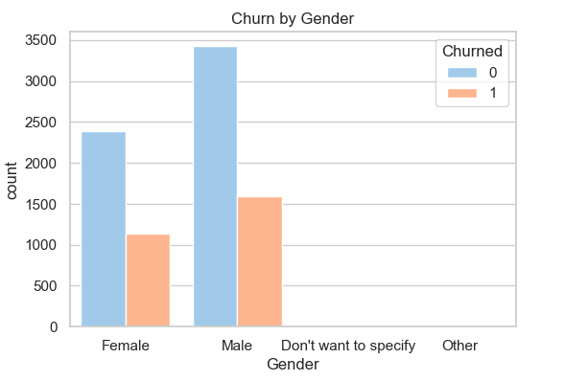
Churn by Region: Learners in North America and South Asia have the highest counts of both retained and churned users.
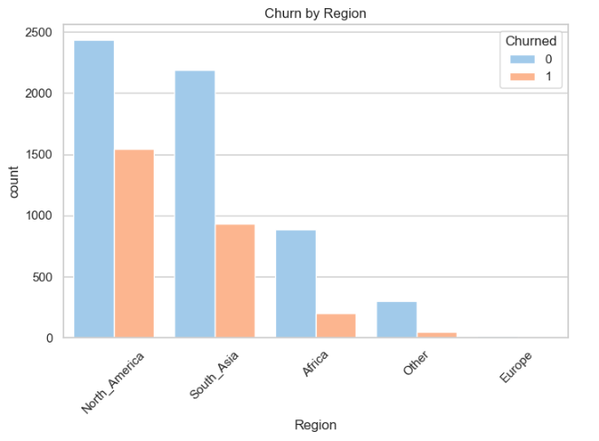
Churn by Age Group: Young adults show the highest numbers of both retained and churned while senior age groups show significantly lower churn rates.
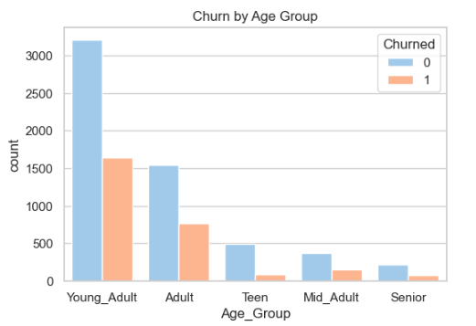

Average Engagement Score by Churn Status: Retained learners have a significantly higher average engagement score than churned learners.
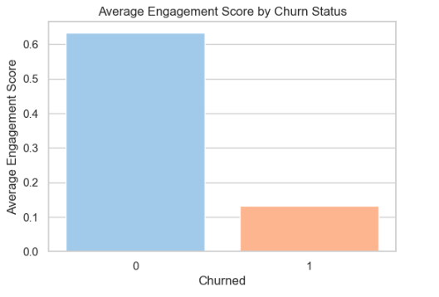
Average Applications per User by Churn Status: Churned users have a higher average number of applications per user than retained users.
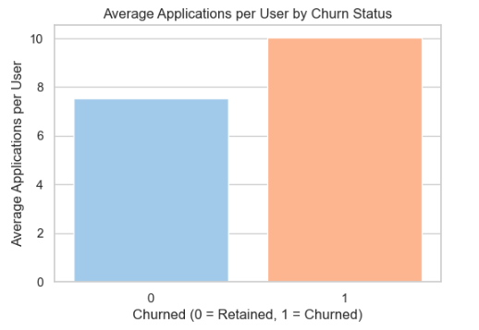
4. Predictive Modeling
- Model Selection:
We applied five machine learning models Logistic Regression, Support Vector Machine (SVM), Random Forest, Gradient Boosting, and XGBoost to predict student churn. Each model was trained on engineered behavioral features and evaluated using accuracy, precision, recall, and F1-score. While all models performed well, Gradient Boosting achieved the highest overall F1-score and demonstrated strong balance between precision and recall. Therefore, Gradient Boosting was selected as the preferred model for churn prediction.
- Model Training:
- Dataset size: 8,558 learners, with a churn rate of 31.81 %.
- Data split: 80% training (6,846 learners) and 20% testing (1,712 learners), stratified to preserve churn distribution.
- SMOTE applied to handle class imbalance.
- StandardScaler applied for models sensitive to scaling.
- Performance Metrics:
Model | Accuracy | Precision | Recall | F1-score | Confusion Matrix
Logistic Regression | 0.7669 | 0.5986 | 0.8128 | 0.6895 | [[870, 297], [102, 443]]
SVM | 0.8768 | 0.7930 | 0.8294 | 0.8108 | [[1049, 118], [93, 452]]
Random Forest | 0.8984 | 0.8354 | 0.8477 | 0.8415 | [[1076, 91], [83, 462]]
Gradient Boosting | 0.9100 | 0.8436 | 0.8807 | 0.8618 | [[1078, 89], [65, 480]]
XGBoost | 0.9077 | 0.8377 | 0.8807 | 0.8587 | [[1074, 93], [65, 480]]

- Feature Importance:
The top features of student churn are:
No. | Feature | Importance
1 | Signup_to_Apply_Days | 0.413958
2 | Course_Duration_Days | 0.362709
3 | Region_Normalized_Applications | 0.103350
4 | Opportunity_Popularity | 0.094250
5 | Quick_Applicant | 0.025632
6 | Late_Applicant | 0.000100

5. Churn Analysis
- Methodology
To accurately identify churned learners, we employed a data-driven approach combining unsupervised clustering and rule-based logic to capture multiple disengagement patterns.
Establishing Behavioral Baselines with KMeans
We used K-Means clustering (n_clusters=2) on four key behavioral features to algorithmically determine natural thresholds between engaged and disengaged users. The midpoint between cluster centroids was used as the threshold for each feature:
- Engagement_Score: 0.3613
- Applications_per_User: 21.91
- User_Success_Rate: 0.4680
- Apply_vs_Start_Gap: –147.46 days
These thresholds represent data-driven benchmarks to identify atypical behavior.
Rule-Based Churn Labeling
A learner was classified as churned (Churned = 1) if they met any of the following five conditions, each designed to capture a distinct disengagement phenotype:
- Low/No Engagement:
Engagement_score below 80% of the threshold OR pre-labeled ‘Low’ engagement level.
- Unsuccessful High Effort:
High application volume (>120% of threshold) coupled with low success rate (<80% of threshold).
- One-and-Done Users:
Applied only once and showed very low engagement (<70% of threshold).
- Early Dropouts:
Left a course long before start (gap <120% of threshold) without success.
- Persistent Failure:
High application volume with very low success rate—repeated attempts without achievement.
Result: This method identified 31.81% of learners as churned.
- Key Factors:
- Signup-to-Apply Delay: The time a learner takes between signing up and submitting their first application.
- Course Duration: The total length of the course in days. Longer courses can overwhelm learners.
- Region-Normalized Applications: The number of applications submitted by learners in a region, normalized for regional differences.
- Opportunity Popularity: How popular or in-demand an opportunity is among learners.
- Quick Applicants: Learners who apply very soon after signing up without exploring options thoroughly.
- Late Applicants: Learners who delay applying for opportunities long after signing up. Delays often reflect indecision or lack of commitment.
- Impact Analysis:
- Signup-to-Apply Delay: Learners who take longer after signup to apply are more likely to churn, indicating lack of initial motivation or poor onboarding.
- Course Duration: Longer courses correlate with higher churn, as learners may feel overwhelmed or lose interest over time.
- Region-Normalized Applications: Regional differences in application behavior affect churn; learners in some regions show consistently lower engagement.
- Opportunity Popularity: Less popular opportunities have higher churn, showing learners prefer trending or competitive opportunities.
- Quick Applicants: Learners who apply too quickly without exploring may churn later, suggesting impulsive behavior with low commitment.
- Late Applicants: Delayed applicants tend to churn more, as they often fail to stay committed.
6. Recommendations
For Signup-to-Apply Delay:
- Strategy: Automate a multi-email onboarding sequence with a video tour and personalized opportunity suggestions to drive immediate action.
- Intervention: Trigger a mentor chat invitation for users who haven't applied within a week to overcome initial hesitation.
For Course Duration:
- Strategy: Restructure long courses into weekly modules, each with a micro-certificate, to prevent learner overwhelm.
- Intervention: Implement automated progress celebration nudges at each milestone to sustain motivation and momentum.
For Region-Normalized Applications:
- Strategy: Develop region-specific content and community hubs to increase local relevance and engagement.
- Intervention: Target users from low-engagement regions with localized banners promoting community forums and events.
- For Opportunity Popularity:
- Strategy: Enhance the recommendation algorithm with collaborative filtering to surface trending and peer-approved opportunities.
- Intervention: Redesign the dashboard to prominently feature "High-Success-Rate" and "Trending" sections to guide user discovery.
For Quick Applicants:
- Strategy: Improve early onboarding to ensure users understand the platform before applying.
- Intervention: Serve a post-application modal guiding impulsive applicants to explore related opportunities, diversifying their choices.
For Late Applicants:
- Strategy: Use AI-driven prompts to re-engage users who show signs of indecision early in their journey.
- Intervention: Send personalized reminders with deadline countdowns and curated opportunity lists to catalyze timely applications.
7. Conclusion
- Summary:
This analysis successfully identified a 31.81% churn rate and its core drivers, with Signup-to-Apply Delay and Course Duration being the most significant predictors. The Gradient Boosting model proved highly effective, accurately pinpointing at-risk learners and confirming that churn is driven by a combination of engagement intensity, learner intent, and opportunity relevance. The insights provide a robust data-driven foundation for shifting from a reactive to a proactive retention strategy.
- Future Work:
- Monitor churn trends over time to capture evolving learner behaviors.
- Incorporate additional behavioral or engagement metrics to improve predictive accuracy.
- Evaluate the impact of implemented interventions and engagement strategies on retention.
- Explore personalized recommendation systems and region-specific campaigns to further reduce churn.

